TUBA CITY UNIFIED SCHOOL DISTRICT #15
DEPARTMENT OF TRANSPORATION
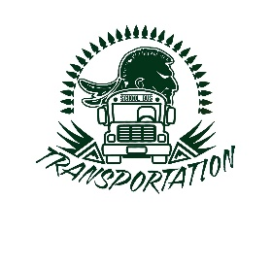
WEEKLY MILEAGE LOG
NAME: __________________________________________ DEPARTMENT:_________________________________
DATE | DESTINATION | UNIT # | START MILEAGE | END MILEAGE | TOTAL MILES | FUEL DATE/ AMOUNT
SIGNATURE OF EMPLOYEE: ______________________________________________ RECEIVED BY: ___________________________
* All authorized drivers are expected to operate vehicles safely and with great care. Maintain the interior and exterior of the vehicle in a clean and
orderly manner. Check vehicle fluids, tires, and lights daily. Always use safe driving practices. Please report unsafe vehicle conditions or
concerns promptly to the Transportation Department. It is recommended that employees refrain from using their cell phones while operating
a motor vehicle. PLEASE BUCKLE YOUR SEAT BELT.
**** MILEAGE LOGS ARE DUE DAILY****

